**Unit-III**

**Concept of Micro Grid:** A **microgrid** is a local [electrical grid](https://en.wikipedia.org/wiki/Electrical_grid) with defined electrical boundaries, acting as a single and controllable entity.[[1]](https://en.wikipedia.org/wiki/Microgrid#cite_note-tsg-1) It is able to operate in grid-connected and in island mode.[[2]](https://en.wikipedia.org/wiki/Microgrid#cite_note-how-microgrids-doe-2)[[3]](https://en.wikipedia.org/wiki/Microgrid#cite_note-IEV-3) A '**Stand-alone microgrid'** or '**isolated microgrid'** only operates [off-the-grid](https://en.wikipedia.org/wiki/Off-the-grid) and cannot be connected to a wider electric power system.[[4]](https://en.wikipedia.org/wiki/Microgrid#cite_note-iec-isolated_microgrid-4)

A grid-connected microgrid normally operates connected to and synchronous with the traditional [wide area synchronous grid](https://en.wikipedia.org/wiki/Wide_area_synchronous_grid) (macrogrid), but is able to disconnect from the interconnected grid and to function autonomously in "island mode" as technical or economic conditions dictate.[[5]](https://en.wikipedia.org/wiki/Microgrid#cite_note-eps-5) In this way, they improve the security of supply within the microgrid cell, and can supply emergency power, changing between island and connected modes.[[5]](https://en.wikipedia.org/wiki/Microgrid#cite_note-eps-5) This kind of grids are called '**islandable microgrids'**.[[6]](https://en.wikipedia.org/wiki/Microgrid#cite_note-vehicle-grid-berkely-6)

A stand-alone microgrid has its own sources of [electricity](https://en.wikipedia.org/wiki/Electricity), supplemented with an [energy storage system](https://en.wikipedia.org/wiki/Battery_storage_power_station). They are used where power transmission and distribution from a major centralized energy source is too far and costly to operate.[[1]](https://en.wikipedia.org/wiki/Microgrid#cite_note-tsg-1) They offer an option for rural electrification in remote areas and on smaller geographical islands.[[4]](https://en.wikipedia.org/wiki/Microgrid#cite_note-iec-isolated_microgrid-4) A stand-alone microgrid can effectively integrate various sources of [distributed generation](https://en.wikipedia.org/wiki/Distributed_generation) (DG), especially [renewable energy sources](https://en.wikipedia.org/wiki/Renewable_energy) (RES).[[1]](https://en.wikipedia.org/wiki/Microgrid#cite_note-tsg-1)

Control and protection are difficulties to microgrids, as all [ancillary services](https://en.wikipedia.org/wiki/Ancillary_service) for system stabilization must be generated within the microgrid and low short-circuit levels can be challenging for selective operation of the protection systems. An important feature is also to provide multiple useful energy needs, such as heating and cooling besides electricity, since this allows energy carrier substitution and increased energy efficiency due to waste heat utilization for heating, domestic hot water, and cooling purposes

**need & applications of micro-grid**

Today’s world depends on an uninterrupted flow of cost-effective electricity. However, many variables, including severe storms, outages, aging infrastructure, and cost pressures can lead to uncertainty in power generation and distribution. Organizations are turning to [microgrids](https://comrent.com/industry-solutions/microgrids/) to lower risks and improve operational performance. Microgrid applications shift control to local users and help them create energy independence.

A microgrid can come in a variety of designs and sizes. It can power a single facility or a large area like a city or college campus. Basic types include remote, customer-owned, and utility distribution. When it comes to electrical testing solutions for microgrids, load banks prove the ideal solution.

A remote microgrid provides power to communities at great distances from utility networks. Customer-owned microgrids work well at large facilities owned by a single entity, such as a military installation, educational institution, and private sector company. A utility distribution microgrid refers to portions of the national grid that acts as microgrids. In each case, these systems generate, distribute, and regulate power to a local group of end users.

‍**Primary Microgrid Applications**Traditionally, microgrids have served remote locations not connected to the central power grid and mission-critical facilities like military installations. However, advancements in technology and increased energy sources have brought microgrids within reach of more business and government organizations. These trends make building and operating a microgrid a more economically feasible solution today and in the future.Microgrids are well-suited to:

* **Organizations Wanting to Lower Energy Costs –** When you provide your power, you can use the lowest cost fuel sources available. You also reduce costs by eliminating power outages. You can connect to the national power grid when it makes sense for your operation. But, fall back on your microgrid for power during outages or when it makes better economic sense. You can also curb the cost of power quality issues in the grid by relying on a microgrid tested by load banks.
* **Organizations Requiring Large Amounts of Reliable Energy --**Municipalities, colleges, manufacturing sites, military installations, government operations, and other users increasingly turn to microgrid applications to deliver their significant energy requirements. They also need a resilient power system that can protect their operation or community during an emergency. Microgrids offer a continuous power solution for facilities that cannot tolerate an outage, such as military bases, hospitals, and research laboratories.
* **Organizations Pursuing Sustainability –**Microgrids offer an efficient solution for incorporating sustainable energy into your operation. Weather conditions and time of day can cause availability and quality issues when renewable energy is used alone. However, microgrids can strategically integrate renewable with non-renewable sources. Their advanced controls can manage the production of renewable energy sources, such as solar photovoltaics and wind turbines, and use them only when it makes sense.

**Applications & Uses**

* Farms
* Mission critical infrastructures
* Municipal facilities
* Government facilities
* Colleges
* Micro Grids
* Hospitals
* Small Business Owners
* Homeowner
* Airports
* Industry

## MICROGRID STRUCTURE AND OPERATION

The distribution generators vary, thus, their microgrid structures.[71](https://onlinelibrary.wiley.com/doi/full/10.1002/2050-7038.12885#etep12885-bib-0071),[72](https://onlinelibrary.wiley.com/doi/full/10.1002/2050-7038.12885#etep12885-bib-0072) The structure of microgrid consists of the five major: (a) microsources or distributed generators, (b) flexible loads, (c) distributed energy storage devices, (d) control systems, and (e) the point of common coupling components, which are connected to a low-voltage distribution network, capable of operating in a controlled, coordinated manner, in both the connected to the utility grid or landed states.[73](https://onlinelibrary.wiley.com/doi/full/10.1002/2050-7038.12885#etep12885-bib-0073),[74](https://onlinelibrary.wiley.com/doi/full/10.1002/2050-7038.12885#etep12885-bib-0074) As to the operation of microgrids, there exist different approaches.[75](https://onlinelibrary.wiley.com/doi/full/10.1002/2050-7038.12885#etep12885-bib-0075) Different types of renewable energy resources are involved as the power generators in a microgrid.[76](https://onlinelibrary.wiley.com/doi/full/10.1002/2050-7038.12885#etep12885-bib-0076)

The components within microgrids form a wide variety. The components of microgrid are shown in Figure [**1**](https://onlinelibrary.wiley.com/doi/full/10.1002/2050-7038.12885#etep12885-fig-0001).[77](https://onlinelibrary.wiley.com/doi/full/10.1002/2050-7038.12885#etep12885-bib-0077) A simplified microgrid system is equipped with (a) controllable generation like diesel generators and load bank, (b) not controllable generators (limited) like the photovoltaic cell[78](https://onlinelibrary.wiley.com/doi/full/10.1002/2050-7038.12885#etep12885-bib-0078),[79](https://onlinelibrary.wiley.com/doi/full/10.1002/2050-7038.12885#etep12885-bib-0079) and wind turbine,[80](https://onlinelibrary.wiley.com/doi/full/10.1002/2050-7038.12885#etep12885-bib-0080),[81](https://onlinelibrary.wiley.com/doi/full/10.1002/2050-7038.12885#etep12885-bib-0081) and (c) distributed energy storage like batteries and super-capacitors is schemed in Figure [**2**](https://onlinelibrary.wiley.com/doi/full/10.1002/2050-7038.12885#etep12885-fig-0002).

[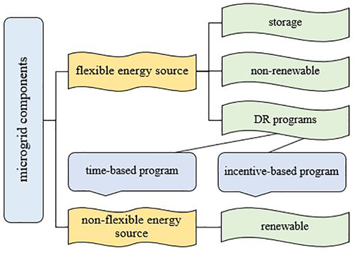](https://onlinelibrary.wiley.com/cms/asset/e03eb4b0-82d9-4228-a1c4-da89131cabdd/etep12885-fig-0001-m.jpg)

**FIGURE 1**

Schematic of a microgrid with different connected energy sources

[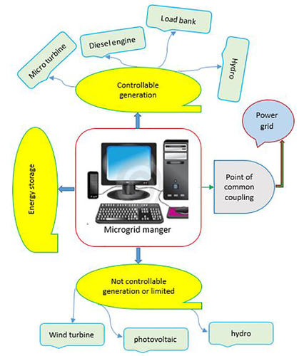](https://onlinelibrary.wiley.com/cms/asset/2e774ab3-853e-4347-9e7a-39146945648c/etep12885-fig-0002-m.jpg)

**FIGURE 2**

Schematic of a microgrid with different connected energy sources

Storage units can balance reserves within short-term to long-term application range.[82](https://onlinelibrary.wiley.com/doi/full/10.1002/2050-7038.12885#etep12885-bib-0082) The microgrid is connected to the upstream network, which can receive the whole or partial energy by the main grid. When connected to a grid, it can both receive or inject power into the main grid, indicating that it can improve the grid efficiency and resolve energy crisis to a certain degree.

**Issues of interconnection in micro grid**

**Power quality, energy management, stability, power flow control, protection system and integration of various distributed generators** are the major issues in the microgrid operation

Micro grid is one of the solutions to present energy crisis. It is basically network comprising of distributed generation sources, storage system and controllable loads, which can operate in grid connected mode or incase of fault in isolated mode. Microgrid provides various advantages to end consumer’s utilities and society. Various advantages include improvement in energy efficiency, minimization of overall energy consumption and improvement in service quality and reliability of power supply [1]. The coexistence of multiple energy sources which have versatile dynamic properties and electrical characteristics have impact on safety, efficiency, control and stability of micro grid. Technical issues associated with operation of micro grid are interconnection and the islanding mode. Interconnection of micro grid with main grid is complex; complexity in interconnection is affected by the types of power generation number of generating sources, location of points of interconnection and level of penetration of micro grid system with main grid [2]. The increased penetration of distributed generation in micro grid system poses several technical problems in the operation of the grid such as steady state and transient over & under voltages at point of connection, protection malfunctions, increase in short circuit levels and power quality problems [3]. The major challenge in micro grid is the protection system. Protection system must respond to both main grid and micro grid faults. Protection system should isolate the micro grid from the main grid as fast as possible to protect the micro grid. When Distributed International Journal of Applied Control, Electrical and Electronics Engineering (IJACEEE) Volume 1, Number 1,May 2013 20 generators (DG) are integrated to form the micro grid it is essential to assure that the loads, lines and DG on island are protected. The fast operation of protection improves the ability to maintain synchronism after transition to islanded operation, which is crucial from viewpoint of stability [4]. The various protection issues arises when the integration of DG is done with distribution level network, there is change in faults current level of network, possibility of sympathetic tripping, reduction in reach of distance relays, loss of relay coordination and unintentional islanding [5]. Protection problem arises in island operation with inverter based sources as inverter based sources are limited by ratings of silicon devices [6]. When micro grid is used to improve service continuity, distributed network protections are needed to be modified. Automatic and fast operative devices are used to detect faulty portion of network, which disconnects it rapidly and automatically it will also reconfigure the network depending upon requirement [7].To overcome problems arising due to bidirectional power flows, low fault current levels in micro grid with inverter based sources a new portion system is required with advanced communication system, with real measurements where settings parameters and relay are checked and updated periodically giving safe and reliable operation.

**protection & control of micro-grid**

Microgrids have been proposed in order to improve reliability and stability of electrical system and to ensure power quality of grid. Microgrid consists of low voltage distribution systems with distributed energy resources, such as wind turbine and photovoltaic power systems, together with storage devices. It is essential to protect a micro grid in both the grid-connected and the islanded mode of operation against all different types of faults. This paper describes micro grid protection and safety concept with central control and monitoring unit where multifunctional intelligent digital relay could be used. This central control & monitoring infrastructure is used for adaptive relay settings strategy for micro grid protection. Also operational safety design concept and fault mitigation technique is proposed to ensure confidence in protection system.

An **organic solar cell** (**OSC**[[1]](https://en.wikipedia.org/wiki/Organic_solar_cell#cite_note-1)) or **plastic solar cell** is a type of photovoltaic that uses [organic electronics](https://en.wikipedia.org/wiki/Organic_electronics), a branch of electronics that deals with conductive organic polymers or small organic molecules,[[2]](https://en.wikipedia.org/wiki/Organic_solar_cell#cite_note-pulfrey-2) for light absorption and charge transport to produce [electricity](https://en.wikipedia.org/wiki/Electricity) from [sunlight](https://en.wikipedia.org/wiki/Sunlight) by the [photovoltaic effect](https://en.wikipedia.org/wiki/Photovoltaic_effect). Most organic photovoltaic cells are **polymer solar cells**.

[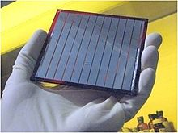](https://en.wikipedia.org/wiki/File:4inchcell.jpg)

Fig. 2. Organic Photovoltaic manufactured by the company Solarmer.

The molecules used in organic solar cells are solution-processable at high throughput and are cheap, resulting in low production costs to fabricate a large volume.[[3]](https://en.wikipedia.org/wiki/Organic_solar_cell#cite_note-3) Combined with the flexibility of organic [molecules](https://en.wikipedia.org/wiki/Molecules), organic solar cells are potentially cost-effective for photovoltaic applications.[[4]](https://en.wikipedia.org/wiki/Organic_solar_cell#cite_note-4) Molecular engineering (*e.g.,* changing the length and [functional group](https://en.wikipedia.org/wiki/Functional_group) of [polymers](https://en.wikipedia.org/wiki/Polymer)) can change the [band gap](https://en.wikipedia.org/wiki/Band_gap), allowing for electronic tunability. The [optical absorption coefficient](https://en.wikipedia.org/wiki/Attenuation_coefficient) of organic molecules is high, so a large amount of light can be absorbed with a small amount of materials, usually on the order of hundreds of nanometers. The main disadvantages associated with organic photovoltaic cells are low [efficiency](https://en.wikipedia.org/wiki/Energy_conversion_efficiency), low stability and low strength compared to inorganic photovoltaic cells such as [silicon solar cells](https://en.wikipedia.org/wiki/Crystalline_silicon).

Compared to [silicon](https://en.wikipedia.org/wiki/Silicon)-based devices, polymer solar cells are lightweight (which is important for small autonomous sensors), potentially disposable and inexpensive to fabricate (sometimes using [printed electronics](https://en.wikipedia.org/wiki/Printed_electronics)), flexible, customizable on the molecular level and potentially have less adverse environmental impact. Polymer solar cells also have the potential to exhibit transparency, suggesting applications in windows, walls, flexible electronics, etc. An example device is shown in Fig. 1. The disadvantages of polymer solar cells are also serious: they offer about 1/3 of the efficiency of hard materials, and experience substantial photochemical degradation.[[5]](https://en.wikipedia.org/wiki/Organic_solar_cell#cite_note-5)

Polymer solar cells inefficiency and stability problems,[[6]](https://en.wikipedia.org/wiki/Organic_solar_cell" \l "cite_note-6) combined with their promise of low costs[[7]](https://en.wikipedia.org/wiki/Organic_solar_cell#cite_note-7) and increased efficiency[[8]](https://en.wikipedia.org/wiki/Organic_solar_cell#cite_note-8) made them a popular field in solar cell research. As of 2015, polymer solar cells were able to achieve over 10% efficiency via a tandem structure.[[9]](https://en.wikipedia.org/wiki/Organic_solar_cell#cite_note-ReferenceA-9) In 2018, a record breaking efficiency for organic photovoltaics of 17.3% was reached via tandem structure

A **thin-film solar cell** is a second generation [solar cell](https://en.wikipedia.org/wiki/Solar_cell) that is made by depositing one or more thin layers, or [thin film](https://en.wikipedia.org/wiki/Thin_film) (TF) of [photovoltaic](https://en.wikipedia.org/wiki/Photovoltaic) material on a substrate, such as glass, plastic or metal. Thin-film solar cells are commercially used in several technologies, including [cadmium telluride](https://en.wikipedia.org/wiki/Cadmium_telluride_photovoltaics) (CdTe), [copper indium gallium diselenide](https://en.wikipedia.org/wiki/Copper_indium_gallium_selenide_solar_cells) (CIGS), and [amorphous thin-film silicon](https://en.wikipedia.org/wiki/Amorphous_silicon) (a-Si, TF-Si).

Film thickness varies from a few nanometers ([nm](https://en.wikipedia.org/wiki/Nanometers)) to tens of micrometers ([µm](https://en.wikipedia.org/wiki/Micrometers)), much thinner than thin-film's rival technology, the conventional, first-generation [crystalline silicon](https://en.wikipedia.org/wiki/Crystalline_silicon) solar cell (c-Si), that uses [wafers](https://en.wikipedia.org/wiki/Silicon_wafer) of up to 200 µm thick. This allows thin film cells to be flexible, and lower in weight. It is used in [building-integrated photovoltaics](https://en.wikipedia.org/wiki/Building_integrated_photovoltaics) and as semi-[transparent](https://en.wikipedia.org/wiki/Transparency_and_translucency), photovoltaic glazing material that can be [laminated](https://en.wikipedia.org/wiki/Window_tinting) onto windows. Other commercial applications use rigid thin film [solar panels](https://en.wikipedia.org/wiki/Solar_panel) (interleaved between two panes of glass) in some of the [world's largest](https://en.wikipedia.org/wiki/List_of_photovoltaic_power_stations) [photovoltaic power stations](https://en.wikipedia.org/wiki/Photovoltaic_power_stations).

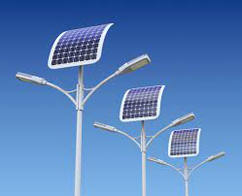

**Variable speed wind generators**

A **variable speed wind turbine** is one which is specifically designed to operate over a wide range of rotor speeds. It is in direct contrast to [fixed speed wind turbine](https://en.wikipedia.org/w/index.php?title=Fixed_speed_wind_turbine&action=edit&redlink=1) where the rotor speed is approximately constant. The reason to vary the rotor speed is to capture the maximum aerodynamic power in the wind, as the wind speed varies. The aerodynamic efficiency, or coefficient of power, {\displaystyle C\_{p}} for a fixed blade pitch angle is obtained by operating the wind turbine at the optimal [tip-speed ratio](https://en.wikipedia.org/wiki/Tip-speed_ratio) as shown in the following graph.

[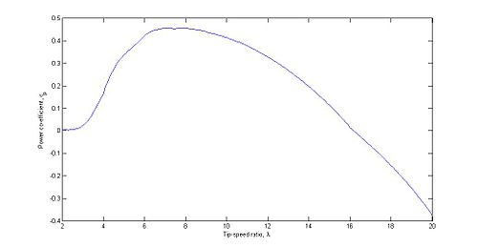](https://en.wikipedia.org/wiki/File:Cplambdadiagram.jpg)

Tip-speed ratio is given by the following expression,

{\displaystyle \lambda ={\frac {\omega R}{v}}}

where {\displaystyle \omega } is the rotor speed (in radians per second), {\displaystyle R} is the radius of the rotor, and {\displaystyle v} is the wind speed. As the wind speed varies, the rotor speed must be varied to maintain peak efficiency.

## Gearboxes[[edit](https://en.wikipedia.org/w/index.php?title=Variable_speed_wind_turbine&action=edit&section=13" \o "Edit section: Gearboxes)]

A variable speed may or may not have a gearbox, depending on the manufacturer's desires. Wind turbines without gearboxes are called direct-drive wind turbines. An advantage of a gearbox is that generators are typically designed to have the rotor rotating at a high speed within the stator. Direct drive wind turbines do not exhibit this feature. A disadvantage of a gearbox is reliability and failure rates.[[4]](https://en.wikipedia.org/wiki/Variable_speed_wind_turbine#cite_note-4)

An example of a wind turbine without a gearbox is the Enercon E82.[[5]](https://en.wikipedia.org/wiki/Variable_speed_wind_turbine#cite_note-5)

## Generators[[edit](https://en.wikipedia.org/w/index.php?title=Variable_speed_wind_turbine&action=edit&section=14" \o "Edit section: Generators)]

For variable speed wind turbines, one of two types of generators can be used: a [DFIG](https://en.wikipedia.org/wiki/Doubly_fed_electric_machine#Double_fed_induction_generator) (doubly fed induction generator) or an [FRC](https://en.wikipedia.org/w/index.php?title=Fully_rated_converter_generator&action=edit&redlink=1) (fully rated converter).

A DFIG generator draws [reactive power](https://en.wikipedia.org/wiki/AC_power#Reactive_power) from the transmission system; this can increase the vulnerability of a transmission system in the event of a failure. A DFIG configuration will require the generator to be a wound rotor;[[6]](https://en.wikipedia.org/wiki/Variable_speed_wind_turbine" \l "cite_note-6) squirrel cage rotors cannot be used for such a configuration.

A fully rated converter can either be an induction generator or a permanent magnet generator. Unlike the DFIG, the FRC can employ a squirrel cage rotor in the generator; an example of this is the Siemens SWT 3.6-107, which is termed the industry workhorse.[[7]](https://en.wikipedia.org/wiki/Variable_speed_wind_turbine#cite_note-7) An example of a permanent magnet generator is the Siemens SWT-2.3-113.[[8]](https://en.wikipedia.org/wiki/Variable_speed_wind_turbine#cite_note-8) A disadvantage of a permanent magnet generator is the cost of materials that need to be included. **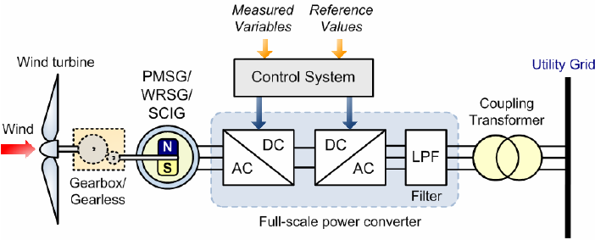**

### Grid Connections[[edit](https://en.wikipedia.org/w/index.php?title=Variable_speed_wind_turbine&action=edit&section=15" \o "Edit section: Grid Connections)]

Consider a variable speed wind turbine with a permanent magnet synchronous generator. The generator produces AC electricity. The frequency of the AC voltage generated by the wind turbine is a function of the speed of the rotor within the generator:

{\displaystyle N={\frac {120f}{P}}}

where {\displaystyle N} is the rotor speed, {\displaystyle P} is the number of poles in the generator, and {\displaystyle f} is the frequency of the output Voltage. That is, as the wind speed varies, the rotor speed varies, and so the frequency of the Voltage varies. This form of electricity cannot be directly connected to a transmission system. Instead, it must be corrected such that its frequency is constant. For this, power converters are employed, which results in the de-coupling of the wind turbine from the transmission system. As more wind turbines are included in a national power system, the inertia is decreased. This means that the frequency of the transmission system is more strongly affected by the loss of a single generating unit.

#### Power converters[[edit](https://en.wikipedia.org/w/index.php?title=Variable_speed_wind_turbine&action=edit&section=16" \o "Edit section: Power converters)]

As already mentioned, the voltage generated by a variable speed wind turbine is non-grid compliant. In order to supply the transmission network with power from these turbines, the signal must be passed through a power converter, which ensures that the frequency of the voltage of the electricity being generated by the wind turbine is the frequency of the transmission system when it is transferred onto the transmission system. Power converters first convert the signal to DC, and then convert the DC signal to an AC signal. Techniques used include [pulse width modulation](https://en.wikipedia.org/wiki/Pulse-width_modulation).

**fuel-cells**

A **fuel cell** is an [electrochemical cell](https://en.wikipedia.org/wiki/Electrochemical_cell) that converts the [chemical energy](https://en.wikipedia.org/wiki/Chemical_energy) of a fuel (often [hydrogen](https://en.wikipedia.org/wiki/Hydrogen_fuel)) and an [oxidizing agent](https://en.wikipedia.org/wiki/Oxidizing_agent) (often oxygen[[1]](https://en.wikipedia.org/wiki/Fuel_cell#cite_note-1)) into electricity through a pair of [redox](https://en.wikipedia.org/wiki/Redox) reactions.[[2]](https://en.wikipedia.org/wiki/Fuel_cell#cite_note-2) Fuel cells are different from most [batteries](https://en.wikipedia.org/wiki/Battery_(electricity)) in requiring a continuous source of fuel and oxygen (usually from air) to sustain the chemical reaction, whereas in a battery the chemical energy usually comes from substances that are already present in the battery.[[3]](https://en.wikipedia.org/wiki/Fuel_cell#cite_note-3) Fuel cells can produce electricity continuously for as long as fuel and oxygen are supplied.

The first fuel cells were invented by Sir [William Grove](https://en.wikipedia.org/wiki/William_Robert_Grove) in 1838. The first commercial use of fuel cells came more than a century later following the invention of the hydrogen–oxygen fuel cell by [Francis Thomas Bacon](https://en.wikipedia.org/wiki/Francis_Thomas_Bacon) in 1932. The [alkaline fuel cell](https://en.wikipedia.org/wiki/Alkaline_fuel_cell), also known as the Bacon fuel cell after its inventor, has been used in [NASA](https://en.wikipedia.org/wiki/NASA) space programs since the mid-1960s to generate power for [satellites](https://en.wikipedia.org/wiki/Satellites) and [space capsules](https://en.wikipedia.org/wiki/Space_capsule). Since then, fuel cells have been used in many other applications. Fuel cells are used for primary and backup power for commercial, industrial and residential buildings and in remote or inaccessible areas. They are also used to power [fuel cell vehicles](https://en.wikipedia.org/wiki/Fuel_cell_vehicle), including forklifts, automobiles, buses, trains, boats, motorcycles and submarines.

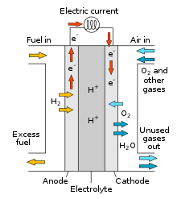

There are many types of fuel cells, but they all consist of an [anode](https://en.wikipedia.org/wiki/Anode), a [cathode](https://en.wikipedia.org/wiki/Cathode), and an [electrolyte](https://en.wikipedia.org/wiki/Electrolyte) that allows ions, often positively charged hydrogen ions (protons), to move between the two sides of the fuel cell. At the anode a catalyst causes the fuel to undergo oxidation reactions that generate ions (often positively charged hydrogen ions) and electrons. The ions move from the anode to the cathode through the electrolyte. At the same time, electrons flow from the anode to the cathode through an external circuit, producing [direct current](https://en.wikipedia.org/wiki/Direct_current) electricity. At the cathode, another catalyst causes ions, electrons, and oxygen to react, forming water and possibly other products. Fuel cells are classified by the type of electrolyte they use and by the difference in startup time ranging from 1 second for [proton-exchange membrane fuel cells](https://en.wikipedia.org/wiki/Proton-exchange_membrane_fuel_cell) (PEM fuel cells, or PEMFC) to 10 minutes for [solid oxide fuel cells](https://en.wikipedia.org/wiki/Solid_oxide_fuel_cell) (SOFC). A related technology is [flow batteries](https://en.wikipedia.org/wiki/Flow_battery), in which the fuel can be regenerated by recharging. Individual fuel cells produce relatively small electrical potentials, about 0.7 volts, so cells are "stacked", or placed in series, to create sufficient voltage to meet an application's requirements.[[4]](https://en.wikipedia.org/wiki/Fuel_cell#cite_note-4) In addition to electricity, fuel cells produce water vapor, heat and, depending on the fuel source, very small amounts of [nitrogen dioxide](https://en.wikipedia.org/wiki/Nitrogen_dioxide) and other emissions. The energy efficiency of a fuel cell is generally between 40 and 60%; however, if waste heat is captured in a [cogeneration](https://en.wikipedia.org/wiki/Cogeneration) scheme, efficiencies of up to 85% can be obtained

**Microturbines**

**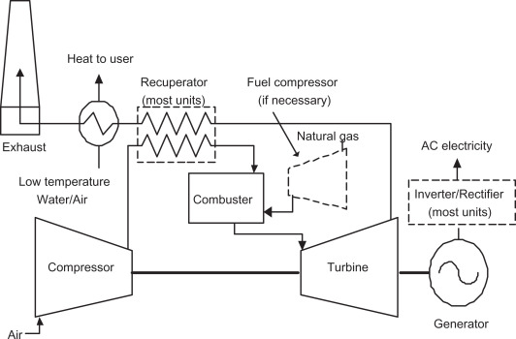**

A **microturbine (MT)** is a small gas turbine with similar cycles and components to a heavy gas turbine. The MT power-to-weight ratio is better than a heavy gas turbine because the reduction of turbine diameters causes an increase in shaft rotational speed. Heavy gas turbine generators are too large and too expensive for distributed power applications, so MTs are developed for small-scale power like electrical power generation alone or as combined cooling, heating, and power (CCHP) systems.[[1]](https://en.wikipedia.org/wiki/Microturbine#cite_note-MGPS2017-1) The MT are 25 to 500 [kilowatt](https://en.wikipedia.org/wiki/Kilowatt) [gas turbines](https://en.wikipedia.org/wiki/Gas_turbine) evolved from piston engine [turbochargers](https://en.wikipedia.org/wiki/Turbocharger), aircraft [auxiliary power units](https://en.wikipedia.org/wiki/Auxiliary_power_unit) (APU) or small [jet engines](https://en.wikipedia.org/wiki/Jet_engine), the size of a [refrigerator](https://en.wikipedia.org/wiki/Refrigerator).[[2]](https://en.wikipedia.org/wiki/Microturbine#cite_note-wbdg22dec2016-2) Early turbines of 30-70 kW grew to 200-250 kW.

**Captive power plants**

**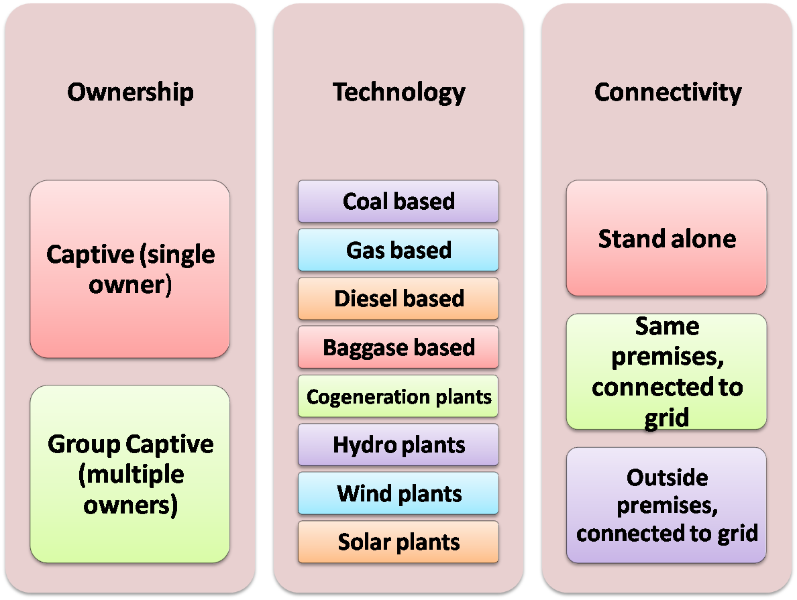**

A **captive power plant**, also called **autoproducer** or **embedded generation**, is an [electricity generation](https://en.wikipedia.org/wiki/Electricity_generation) facility used and managed by an industrial or commercial energy user for their own energy consumption. Captive power plants can operate [off-grid](https://en.wikipedia.org/wiki/Off-grid) or they can be connected to the electric grid to exchange excess generation.[[1]](https://en.wikipedia.org/wiki/Captive_power_plant#cite_note-1)[[2]](https://en.wikipedia.org/wiki/Captive_power_plant#cite_note-2)

Captive power plants are generally used by power-intensive industries where continuity and quality of energy supply are crucial, such as [aluminum smelters](https://en.wikipedia.org/wiki/Aluminum_smelter), [steel plants](https://en.wikipedia.org/wiki/Steel_plant), [chemical plants](https://en.wikipedia.org/wiki/Chemical_plant), etc.[[3]](https://en.wikipedia.org/wiki/Captive_power_plant#cite_note-3) However, the radical cost declines for [solar power](https://en.wikipedia.org/wiki/Solar_power) systems have enabled the opportunity for less energy intensive industries to economically [grid defect](https://en.wikipedia.org/wiki/Grid_defection) by coupling solar PV with generators or [cogeneration](https://en.wikipedia.org/wiki/Cogeneration) units along with [battery](https://en.wikipedia.org/wiki/Electrical_battery) systems.

**Integration of renewable energy sources**

Renewable energy production from some sources such as wind and solar is more variable and more geographically spread than technology based on fossil fuels and nuclear. While integrating it into the wider energy system is feasible, it does lead to some additional challenges such as increased production volatility and decreased system inertia.[[131]](https://en.wikipedia.org/wiki/Renewable_energy#cite_note-Olauson_16175-131) Implementation of energy storage, using a wide variety of renewable energy technologies, and implementing a [smart grid](https://en.wikipedia.org/wiki/Smart_grid) in which energy is automatically used at the moment it is produced can reduce risks and costs of renewable energy implementation.[[131]](https://en.wikipedia.org/wiki/Renewable_energy#cite_note-Olauson_16175-131)[[132]](https://en.wikipedia.org/wiki/Renewable_energy#cite_note-FOOTNOTEIPCC201115%E2%80%9316-132)

Sector coupling of the power generation sector with other sectors may increase flexibility: for example the transport sector can be coupled by charging electric vehicles and sending electricity from [vehicle to grid](https://en.wikipedia.org/wiki/Vehicle-to-grid).[[133]](https://en.wikipedia.org/wiki/Renewable_energy#cite_note-133) Similarly the industry sector can be coupled by hydrogen produced by electrolysis,[[134]](https://en.wikipedia.org/wiki/Renewable_energy#cite_note-134) and the buildings sector by thermal energy storage for space heating and cooling.